Experiment: 4 Date:

Simple Hill Climbing Algorithm

AIM: To implement the Simple Hill Climbing Algorithm.

Theory:

Hill Climbing is a local search algorithm used in Artificial Intelligence to find a better solution by continuously moving from the current state to a better neighboring state.
The algorithm starts with an initial state and evaluates its neighboring states. If a better neighboring state is found, the algorithm moves to that state. This process continues until no better neighboring state is available.

In Simple Hill Climbing, the neighboring states are examined one at a time. As soon as a better neighbor is found, the algorithm moves to that state without examining the remaining neighbors. Hill climbing can be used for both maximization and minimization problems.

Important Concepts in Hill Climbing

1. Global Maximum
A global maximum is the state having the highest value among all possible states in the search space.
It represents the best possible solution for a maximization problem.

2. Local Maximum
A local maximum is a state whose value is better than the values of its immediate neighboring states, but it may not be the highest value in the entire search space.
Hill climbing can stop at a local maximum even when a better global maximum exists elsewhere.

3. Global Minimum
A global minimum is the state having the lowest value among all possible states in the search space.
It represents the best possible solution for a minimization problem.

4. Local Minimum
A local minimum is a state whose value is lower than the values of its neighboring states, but it may not be the lowest value in the entire search space.
For a minimization problem, hill climbing attempts to move toward states with lower values.

5. Plateau
A plateau is an area in the search space where neighboring states have the same or nearly the same evaluation value. Since there is no clearly better neighboring state, the algorithm may stop or have difficulty deciding which direction to move.

Characteristics of Simple Hill Climbing
- It is a local search technique.
- It evaluates neighboring states of the current state.
- It moves to the first better neighboring state found.
- It requires very little memory.
- It does not maintain a search tree.
- It can get stuck at a local maximum or local minimum.
- It may have difficulty when it encounters a plateau.
- The solution may depend on the initial state.
- It does not always guarantee the global optimum.

ALGORITHM:

- Start with an initial state.
- Evaluate the current state.
- Generate a neighboring state.
- Compare the neighbor with the current state.
- If the neighbor is better, move to the neighbor.
- Continue the process until no better neighboring state is found.
- Return the current state as the solution.

Example:
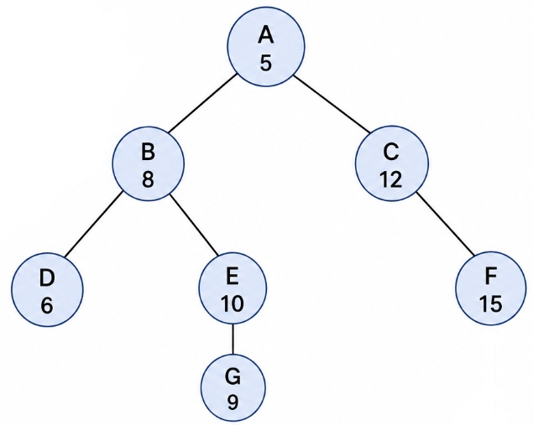

Consider the following graph. The numbers inside the nodes represent the heuristic/evaluation value of each state. Since this is a maximization problem, the algorithm always tries to move toward a neighboring node with a higher value.

Suppose the algorithm starts at A(5).

Step | Current State | Neighbors Examined | Action
1 | A(5) | B(8), C(12) | Move to B(8)
2 | B(8) | D(6), E(10) | Move to E(10)
3 | E(10) | G(9) | No better neighbor → Stop

So the algorithm reaches E(10) and stops.
However, notice that C(12) → F(15) contains a better solution. The algorithm does not reach it because Simple Hill Climbing moves to the first better neighbor it encounters.
Therefore:
- E(10) → Local Maximum
- F(15) → Global Maximum
- The algorithm gets stuck at the local maximum.

CODE:

OUTPUT:

CONCLUSION:

